**Shrub-animal density dependence in desert ecosystems**

**April 2019 Progress Report**

**Mario Zuliani & Chris Lortie**

**Committee:**

Chris Lortie (Supervisor)

Greg Thiemann (Committee Member)

**Background**

Positive interactions between plant and animal species have been reported in most ecosystems globally. Positive interactions are defined as non-trophic interactions between species where at least one of the interacting species has a positive benefit towards their overall fitness, while the other remains unaffected (Bertness & Callaway 1994, Molina-Montenegro et al. 2016). While there are documentations of many types of interactions that are negative towards one species and positive towards the other, such as predation, a significant number of studies have arisen where only positive interactions are analyzed (Bertness & Callaway 1994, Kéfi et al. 2016). The term used to describe these positive interactions is facilitation where species interactions are usually beneficial to at least one of the species (Kikvidze & Callaway 2006, Kéfi et al. 2016). These interactions are classified as facilitation as long as none of the species in the interaction are experiencing any adverse negative effects that could hinder its survival (Bertness & Callawat 1994, Bruno et al. 2003, Grinath et al. 2012). In semi-arid/arid environments, it is proposed that these types of positive interactions, between plant-plant, plant-animal and animal-animal, often occur more frequently and are more prevalent (Holzaphel & Bruce 1999, Stachowicz 2001). In many of the cases where facilitation occurs in these arid/semi-arid environments, it has been proposed that without this interaction, many species would not be able to survive and would have their overall survival hindered (Holzaphel & Bruce 1999). Shrubs are able to facilitate these positive interactions either directly through shrub-animal-plant interactions or through a more indirect pathway being, shrub-plant-animal (Lortie et al. 2016). Shrubs can provide a variety of positive interactions for animals including; acting as a resource, protecting from predators and being a refuge for different species (Vázquez et al. 2009, Lortie et al. 2018). The shrubs can also indirectly benefit plant and animal species that take refuge under the canopy cover by creating a microhabitat for these species (Noble et al. 2016). Species such as the blunt nosed leopard lizard depend on this type of interaction to cool during the warmer seasons (Noble et al.2016, Westphal et al.2018). Reciprocally, animals interacting with the shrub can also provide positive services including dispersing the shrubs seeds, pollinating the shrub, and by consuming herbivorous species or competitor species near the shrub (Vázquez et al. 2009, Lortie et al. 2016). These interaction complexes provide a rich opportunity to explore resilience in biodiversity in dryland ecosystems.

Shrubs can provide benefits to animal communities through different mechanistic pathways (Bertness et al. 1997, Bortolus et al. 2002, Lortie et al. 2016). Environments that display extreme conditions are excellent areas to display these types of positive interactions between shrubs and animals because of relatively high stress (Bertness & Callaway 1994). The resources, such as shelter and food, have a critical influence on the survival of a species and could impact the presence of the species and its total population (Hughes 2012, Rey et al. 2018). Shrubs can act as foundation species in arid environments structuring the biodiversity at large (Filazzola & Lortie, 2014, Lortie et al. 2018). There are both direct and indirect interactions with benefactors in the facilitation literature (Grinath et al. 2012, Lortie et al. 2016, Lortie et al. 2018). Direct interactions include acting as a resource, protecting from predators, acting as a refuge and providing a food source. Indirect interactions are those that are interactions between species that are not done through direct means such as the production of a microclimate under a shrub canopy. Indirect interactions are less commonly tested (Hughes 2012). Restoration of these areas will require both evidence for direct and indirect interactions that foundation species provide and knowing when within each locale different drivers are relatively more important (Suding et al. 2004). Direct and indirect facilitation pathways can also be connected to one another and dependent on the densities of these types of species.

Density is a fundamental concept in population and community ecology. Shrub population densities could have a large impact on the interactions experienced by various different species both plant and animal (Springer et al. 2003, Tietje et al. 2008). Density is defined as the total number of individuals in a given area, or per unit area (Lyon 1968). From this we can define shrub density to be the total number of shrub individual in a defined given area (Lyon 1968). Since foundational shrub species show both direct and indirect interactions with plants and animals species (Hughes 2012), it is possible that the density of these shrubs could have a positive or negative effect on the population densities of. Some studies have shown that some species prefer shrub cover as opposed to open areas as they provide better microhabitats and movement trails (Stapp and Van Horne 1997). There has been a significant lack of studies conducted on the shrub and animal densities correlation, especially in arid ecosystems. Shrubs consist of a microclimate underneath their canopy cover that proves to be favorable for species to escape harsh climate of arid landscapes, which usually results in a larger species density being noted, due to increased beneficial interactions (Hanley 1978, Koyama et al. 2015). In areas that are considered arid or semi-arid, shrubs that are found at low densities areas have a trend of increasing in overall density, which is especially seen after the cessation of disturbances (Musick et al. 1998). Animal density can respond to variations in shrub density (Skarpe 1990) and to habitat stressors (Bertness & Callaway 1994). Populations of herbivores could potentially fluctuate with changes to woody shrub abundance, thus suggesting that there may be some connection between the two densities (Skarpe 1990).

**Chapter 1: Making a Deal with the Devil: A Systematic Review of the plant-animal interactions**

**Purpose:**

The purpose of the systematic review is to examine the relationship between shrub and animal densities, that have been recorded in literature. Facilitation will be will be searched for reported shrub density measure.

**Research Questions**:

What types of direct and indirect interactions are occurring around shrubs?

If there are interactions between plant and animal species, then is facilitation being observed?

Are the interactions between these species having direct or indirect effects?

Are the shrub densities measured in these studies?

**Progress to Date:**

**Search Strategy:**

A total of 375 papers were examined from searches on the Web of Science. Filters included the key words “facil* density* shrub*”, “density* shrub* facilitate*” and “density* shrub* animal* facil*.”

**Eligibility Criteria:**

Papers were excluded based on the following criteria: (1) what field of study is the paper focusing on, (2) is density, facilitation and shrub mentioned in the abstract, (3) is there density data usable in the paper, (4) are the benefactor and protégé species mentioned, (5) do the papers pertain to the field of ecology.

**Methods:**

Duplicates were excluded from the 375 papers and then the abstract review had begun. After abstract review and full text review have been left with a total of 37. While going through text review I looked for a few key factors in the paper that would prove useful for the systematic review. First, I wanted to ensure the remaining papers included a measure of shrub density. Almost all the papers included some measure of density. Unit of density measurement was then recorded to see the differing methods of calculating the overall abundance of shrubs in these varying papers. Finally, I ensured that the papers I was going through for the systematic review were able to conclude, or were able to make connections to facilitative interactions. To do this I determined whether or not the papers concluded that this was occurring in their system. If the paper concluded that facilitation was evident then it was denoted with a Yes, and if they concluded that there were no facilitative interactions, it was denoted with a No.

**Chapter 1 Progress:**

**Identification**

Papers obtained through searching Web of Science database.

Key Words:

density* facilitation* shrub

shrub* density* facilitate*

density* shrub* animal* facilitate*

(n = 375)

Papers obtained from other sources, such as books and other databases

Records after duplicates removed

(n = 375)

Items screened based on relevance to field of Ecology

(n = 278)

Items Excluded

(n = 97)

**Screening and Eligibility**

Items screened based on Abstract

(n = 74)

Items Excluded

(n = 204)

Items screened based on work mentioning shrub density with facilitation.

(n = 37)

Items Excluded

(n = 37)

Items Included in final Synthesis

(n = 37)

**Included**

**Figure 1:** PRISMA diagram (Moher et al, 2009) of workflow for plant-animal density systematic review.

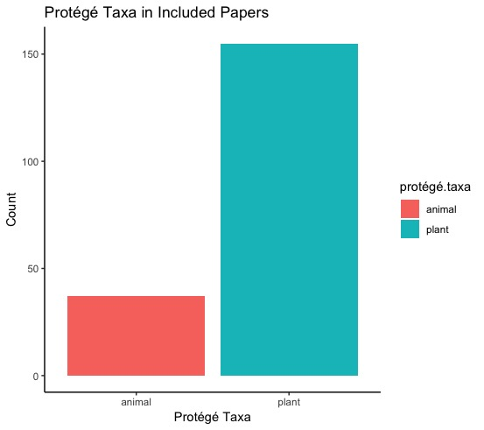

**Figure 2:** A bar graph displaying the protégé taxa observed in all papers that will be included in the systematic review, including all papers with and without density data. A total of 37 data points look at animals as the protégé taxa and 155 points look at plants as the protégé taxa.

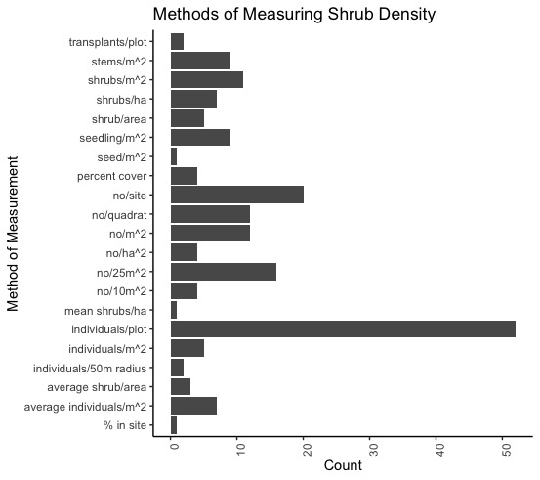

**Figure 3:** The bar graph displays the different measures of density from the papers filtered for the systematic review. Some studies did not give an exact measure, such as the parameters for a site or plot, which can be seen with some measures as individuals/plot and no/site. There are some instances where a site is given proper units such as M2 or a radius.

**Results:**

From the data so far, I noticed that the most frequently observed protégé taxa was plant species, suggesting that most of the papers are focusing on plant-plant facilitative interactions than plant-animal interactions (Figure 2). The data displays over 150 different density data points pertaining to plants as the protégé species as opposed to the under 40 data points seen with animals as protégé species (Figure 2).

From looking at the measurement data from each of the papers, it is evident that there is no agreed upon unit to measure the density of a given area. Many of the papers used a unit of measurement suitable for their specific site, so if a site had a diameter of 10m, then the measurement was shrub/10m (Figure 3). From the data collected the most frequent unit of measurement noted is individuals/plot as there were over 50 data points that had this as their unit of measurement (Figure 3).

**Chapter 1 Next Steps:**

The next steps for my Chapter 1 is to continue analyzing the data I have gathered from the selected 37 papers, by; collecting the latitude and longitude of the study locations, generating a map of all study locations, and attempt to convert the densities into values that are consistent with one another instead of having multiple different values. I hope to get a large portion of additional data analysis complete before the beginning of my field season in May and begin writing a rough copy of the Chapter 1 manuscript upon returning from my field season.

**Chapter 2: Shrub-animal density dependence in desert ecosystems.**

**Purpose:**

The purpose of the experiment is to examine the importance of density of shrub and animal species in a desert ecosystem, including measures of local stress.

**Research Questions:**

Is there a relationship between shrub and animal densities in the Carrizo Plain?

Does the local context influence the importance of density, i.e. environmental stress measures?

Does shrub size matter?

**Hypothesis**

Frequency of shrub and animal interactions will increase at higher densities, due to an increase in facilitative interaction, and may be influenced by local environmental stressors.

**Predictions:**

1. Higher Shrub density will correlate with a higher animal species density.
2. Shrub and animal densities within a site are positively density dependent
3. High shrub densities also increase animal species richness
4. Larger shrub size will have a positive impact on animal density

**Methods:**

**Camera Traps and Density Mapping:**

Once the shrub densities have been determined and a corresponding gradient for Low, Medium and High density is established, camera traps will be deployed in the field. The Camera traps will be distributed at 2 separate study sites on the Elkhorn. The total number of cameras is as follows:

2 Sites x 4 density gradient (Low, Medium, High, None) X 2 (2 at each site) x 10 Reps = 160 Sets of data

2 cameras will be placed at each study site. Both of the cameras will be station looking into its designated microsite and will be placed at opposite sides. These traps will remain at the site untouched for a “Week” which will be classified as a 3 day cycle. Cameras will be set to the video function and will have a 5 second run time when triggered by movement. Once cameras have been removed and the corresponding SD cards are labeled and downloaded onto a hard drive, an excel sheet will be generated and used for data analysis. The sheet will consist of: date, rep, day, week, microsite, animal.hit, RTU, time.block, actual.time, start, stop, behavior, and observations. From there the total number of “hits” and “false hits” will be organized. From there an analysis will be conducted to show the total number of hits in the areas that are classified as High, Medium, Low and No shrub densities.

**Stress Measurement:**

Stress of each microsite is going to be measured by deploying a logger at each of the established sites. A total if 8 loggers will be deployed, to record the varying light and temperature at each microsite. The loggers will be left there for the duration of the experiment, then removed and uploaded to a computer database where they will be analyzed.

**Transect:**

In addition to camera traps, transects will be set up along the sites (High medium and low shrub density) to gather more measurements on shrub densities in the area, as well as observing any animal activity or presence along the transects. The total of 9 transects per site will be set up and will be located as close as possible to each of the microsites, High, medium and Low densities. This allows for a total of 3 transects per microsite, with 2 sites, resulting in 18 transects being set up. A 100m transect will be set up randomly along the microsite and will be run every 3-4 days, for about a month. From there, every 2 meters along the transect, the total shrub density will be recorded in a 10m radius. This will continue from 0m to 100m on the transect. GPS locations for the beginning and end of the transects will be taken and recorded. While continuing on the transect any animal observations will be noted on the corresponding section of the transect. These animals must be within the 10m radius along the transect, to count towards the transect recordings.

**Focal Observations:**

The Final portion of the study is to include several hours of focal observations. A few hours will be dedicated to each site where any observed animal will be recorded. Recordings including GPS location, which site the animal is found and activity will be noted. This will be conducted at the same time as the Camera traps are deployed in the field. Recordings will be taken whenever an animal is found during the observations. When found time will be noted as well as the type of animal, its behavior, its corresponding location, distance to shrub, and if possible how dense the shrubs are in the area. An hour will be dedicated to each microsite and will involve a researcher walking around the site until continuing to the next.

**Progress to Date:**

A pilot project was conducted in California this January 2019. During this field season, the suggested protocol was tested at the Panoche Plateau to see how it would be conducted in the Carrizo Plain. The protocol was not tested at the main field site due to unusually heavy rains. With the data collected from the practice sites, figures were generated to display the average number of shrubs found in each microsite, thus displaying what I hope to see at my microsites in the Carrizo Plain.

Most equipment is purchased and ready to go for the May field season. 16 camera traps are ready at NCEAS in Santa Barbara, California. The last piece of equipment left to purchase is 8 light and temperature loggers for measuring the stressors at each microsite.

I have secured satellite imagery of the Carrizo Plain sites, thanks to the help of a researcher and collaborator in my lab. Using this satellite imagery we were able to determine the densities of both sites on the Carrizo Plain.

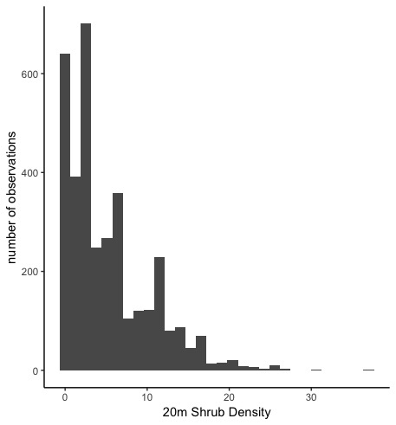

**Figure 4**: Total *Ephedra Californica* density in a 20m radius at site 4 in the Carrizo Plain in 2016, 2017 and 2018.

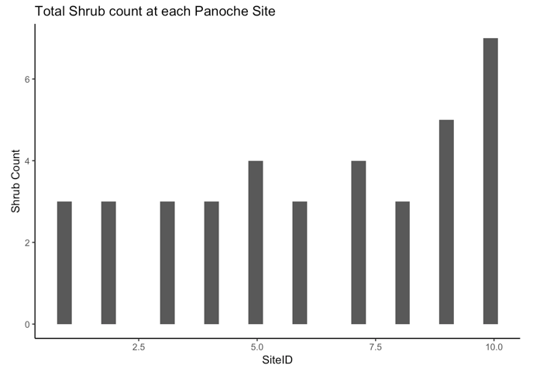

**Figure 5:** A bar graph displaying the varying shrub densities at each microsite in the Panoche Plateau. Densities ranged from as low as 3 shrubs in a microsite, to as many as 7, as seen in microsite 10.

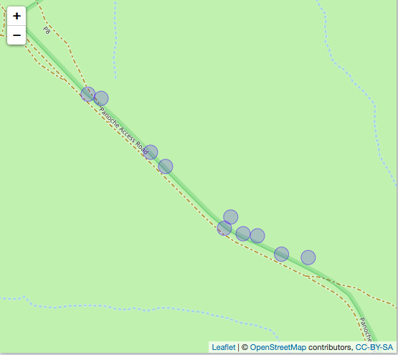

**Figure 6:** A generated map displaying the locations of all test microsites in the Panoche Plateau. The map displays the radius of each individual microsite as well as the approximate location of each site.

**Findings so far:**

From this practice field season and the data collected from establishing trial microsites, it was evident that there is a fairly wide variety of diverse locations that can be used to compare different shrub densities. While this is not site where the experiment will be conducted, I believe that it gives a good depiction of what I hope to achieve in the Carrizo Plain. Figure 5, displays the varying shrub densities at the established trial microsites at the Panoche Plateau. Many of these microsites had a density of 3 shrubs, which would be considered to be a low shrub density, where as we had one microsite that contained a high density of shrubs, acting as a high density area. In addition, sites 5, 7 and 9 had 4-5 shrubs per site, which would act as a medium shrub density microsite. No camera data or transect data was taken during this trial field season due to time constraints and other limitations.

Figure 6 is a display of the GPS locations of each of the microsites on the Panoche Plateau. The plateau itself was fairly plain with varying densities of shrub scattered throughout the site itself. The sites were randomly chosen, with close proximity to the main path and then measured using a transect tape. Each Ephedra shrub within the site was measured and it’s GPS location was taken. Measurements included; x being the longest length of the shrub, y being 90 degreed from the x measurement and then z being the height of the shrub.

**Upcoming Plans:**

The next phase of the project will be to continue working on Chapter 1, analyzing the data taken from papers further and begin the written portion for the systematic review. I need to order the data loggers that are going to be deployed at each microsite and have them shipped to NCEAS in Santa Barbara before the field season begins. I plan on heading out to California around May 15th where I will begin working on Chapter 2 of the projects, measuring sites, deploying camera traps, running transects and conducting focal observations. I will then return around June 15th and begin analyzing the data recorded in the field and start processing camera trap video data.

**Timeline:**

Table 2: Timeline for Chapter 1 and 2 Research.

|  |  |
| --- | --- |
| **Timeline** | **Goals** |
| February 2019 | Travel to Carrizo study site to get preliminary data on potential sites. Pick potential sites.  **Complete** |
| March 2019 | Work with data collected from February trip. |
| April 2019 | Continue working with data collected from February trip, work on write up for Chapter 1 |
| May 2019 | Travel to Carrizo site, acquire camera traps and SD cards. Deploy cameras at sites (Chosen in February). Conduct focal observations and transects |
| June 2019 | Return from field site. Begin analyzing data from camera traps, transects and focal observations. Continue work on Chapter 1 if not yet completed |
| July 2019 | Continue working with dataset from May field month. Continue work on Chapter 1. |

**References:**

Bertness, Mark D., and Ragan Callaway. 1994. “Positive Interactions in Communities.” Trends in Ecology & Evolution 9 (5): 191–93.

Bertness, Mark D., and George H. Leonard. 1997. “The Role of Positive Interactions in Communities: Lessons from Intertidal Habitats.” Ecology 78 (7): 1976.

Bortolus, Alejandro, Evangelina Schwindt, and Oscar Iribarne. 2002. “Positive Plant-Animal Interactions in the High Marsh of an Argentinean Coastal Lagoon,” 11.

Bruno, J. F., Stachowicz, J. J., & Bertness, M. D. (2003). “Inclusion of facilitation into ecological theory.” Trends in Ecology & Evolution, 18(3), 119-125.

Filazzola, Alessandro, Amanda Rae Liczner, Michael Westphal, and Christopher J. Lortie. 2018. “The Effect of Consumer Pressure and Abiotic Stress on Positive Plant Interactions Are Mediated by Extreme Climatic Events.” New Phytologist 217 (1): 140–50.

Filazzola, Alessandro, and Christopher J. Lortie. 2014. “A Systematic Review and Conceptual Framework for the Mechanistic Pathways of Nurse Plants: A Systematic Review of Nurse-Plant Mechanisms.” Global Ecology and Biogeography 23 (12): 1335–45.

Grinath, Joshua B., Brian D. Inouye, Nora Underwood, and Ian Billick. 2012. “The Indirect Consequences of a Mutualism: Comparing Positive and Negative Components of the Net Interaction between Honeydew-Tending Ants and Host Plants: Decomposing a Net Indirect Interaction.” Journal of Animal Ecology 81 (2): 494–502.

Hanley, Thomas A. 1978. “A Comparison of the Line-Interception and Quadrat Estimation Methods of Determining Shrub Canopy Coverage.” Journal of Range Management 31 (1): 60.

Hawbecker, Albert C. 1951. “Small Mammal Relationships in an Ephedra Community.” Journal of Mammalogy 32 (1): 50.

Holzapfel, Claus, and Bruce E Mahall. 1999 “Bidirectional Facilitation and Interference between Shrubs and Annuals in the Mojave Desert,” 16.

Hughes, A. Randall. 2012. “A Neighboring Plant Species Creates Associational Refuge for Consumer and Host.” Ecology 93 (6): 1411–20.

Kéfi, Sonia, Milena Holmgren, and Marten Scheffer. 2016. “When Can Positive Interactions Cause Alternative Stable States in Ecosystems?” Edited by Francisco Pugnaire. Functional Ecology 30 (1): 88–97.

Kikvidze, Zaal, and Ragan M. Callaway. 2009. “Ecological Facilitation May Drive Major Evolutionary Transitions.” BioScience 59 (5): 399–404.

Koyama, A., T. Sasaki, U. Jamsran, and T. Okuro. 2015. “Shrub Cover Regulates Population Dynamics of Herbaceous Plants at Individual Shrub Scale on the Mongolian Steppe.” Edited by Francisco Pugnaire. Journal of Vegetation Science 26 (3): 441–51.

Lortie, Christopher J., Alessandro Filazzola, and Diego A. Sotomayor. 2016. “Functional Assessment of Animal Interactions with Shrub-Facilitation Complexes: A Formal Synthesis and Conceptual Framework.” Edited by Richard Michalet. Functional Ecology 30 (1): 41–51

Lortie, Christopher J., Eva Gruber, Alex Filazzola, Taylor Noble, and Michael Westphal. 2018. “The Groot Effect: Plant Facilitation and Desert Shrub Regrowth Following Extensive Damage.” Ecology and Evolution 8 (1): 706–15

Lyon, L. Jack. 1968. “An Evaluation of Density Sampling Methods in a Shrub Community.” Journal of Range Management 21 (1): 16.

Moher, David, Alessandro Liberati, Jennifer Tetzlaff, and Douglas G. Altman. 2010. “Preferred Reporting Items for Systematic Reviews and Meta-Analyses: The PRISMA Statement.” International Journal of Surgery 8 (5): 336–41.

Molina-Montenegro, Marco A., Rómulo Oses, Ian S. Acuña-Rodríguez, Cristian Fardella, Ernesto I. Badano, Patricio Torres-Morales, Jorge Gallardo-Cerda, and Cristian Torres-Díaz. 2016. “Positive Interactions by Cushion Plants in High Mountains: Fact or Artifact?” Journal of Plant Ecology 9 (2): 117–23. https://doi.org/10.1093/jpe/rtv044.

Musick, H Brad, Gerald S Schaber, and Carol S Breed. 1998. “AIRSAR Studies of Woody Shrub Density in Semiarid Rangeland: Jornada Del Muerto, New Mexico,” 12.

Noble, Taylor J., Christopher J. Lortie, Michael Westphal, and H. Scott Butterfield. 2016. “A Picture Is Worth a Thousand Data Points: An Imagery Dataset of Paired Shrub-Open Microsites within the Carrizo Plain National Monument.” GigaScience 5 (1).

Prugh, Laura, and Justin Brashares. 2010. “Basking in the Moonlight? Effect of Illumination on Capture Success of the Endangered Giant Kangaroo Rat.” Journal of Mammalogy 91 (5): 1205–12.

Rey, P. J., I. Cancio, A. J. Manzaneda, A. González-Robles, F. Valera, T. Salido, and J. M. Alcántara. 2018. “Regeneration of a Keystone Semiarid Shrub over Its Range in Spain: Habitat Degradation Overrides the Positive Effects of Plant-Animal Mutualisms.” Edited by D. Byers. Plant Biology 20 (6): 1083–92.

Rowcliffe, J. Marcus, Juliet Field, Samuel T. Turvey, and Chris Carbone. 2008. “Estimating Animal Density Using Camera Traps without the Need for Individual Recognition.” Journal of Applied Ecology 45 (4): 1228–36.

Skarpe, Christina. 1990. “Shrub Layer Dynamics Under Different Herbivore Densities in an Arid Savanna, Botswana.” The Journal of Applied Ecology 27 (3): 873.

Springer, T. L., C. L. Dewald, P. L. Sims, and R. L. Gillen. 2003. “How Does Plant Population Density Affect the Forage Yield of Eastern Gamagrass?” Crop Science 43 (6): 2206.

Stachowicz, John J. 2001. “Mutualism, Facilitation, and the Structure of Ecological Communities.” BioScience 51 (3): 235.

Stapp, P., and B. Van Horne. 1997. “Response of Deer Mice (Peromyscus Maniculatus) to Shrubs in Shortgrass Prairie: Linking Small-Scale Movements and the Spatial Distribution of Individuals.” Functional Ecology 11 (5): 644–51

Suding, Katharine N., Katherine L. Gross, and Gregory R. Houseman. 2004. “Alternative States and Positive Feedbacks in Restoration Ecology.” Trends in Ecology & Evolution 19 (1): 46–53

Tietje, William D., Derek E. Lee, and Justin K. Vreeland. 2008. “Survival and Abundance Of Three Species Of Mice In Relation to Density Of Shrubs and Prescribed Fire In Understory Of An Oak Woodland In California.” The Southwestern Naturalist 53 (3): 357–69.

Vázquez, Diego P., Nico Blüthgen, Luciano Cagnolo, and Natacha P. Chacoff. 2009. “Uniting Pattern and Process in Plant–Animal Mutualistic Networks: A Review.” Annals of Botany 103 (9): 1445–57.

Westphal, Michael F., Taylor Noble, Harry Scott Butterfield, and Christopher J. Lortie. 2018. “A Test of Desert Shrub Facilitation via Radiotelemetric Monitoring of a Diurnal Lizard.” Ecology and Evolution, November.